Online Food Delivery Data Analysis using SQL

1.Project Title:Online Food Delivery Data Analysis using SQL
Developed By: Swetha A

2. Objective:
To analyze food delivery data using SQL and derive business insights like restaurant performance, customer loyalty, and order trends.

3. Tools Used:
- MySQL Workbench
- SQL
- Dataset: Customers, Restaurants, Orders, Ratings

4. Database Schema:
Tables & Columns:

Customers
- CustomerID (PK)
- CustomerName
- Email

Restaurants
- RestaurantID (PK)
- Name
- Cuisine

Orders
- OrderID (PK)
- CustomerID (FK)
- RestaurantID (FK)
- OrderDate
- Amount

Ratings
- RatingID (PK)
- CustomerID (FK)
- RestaurantID (FK)
- Score (1–5)
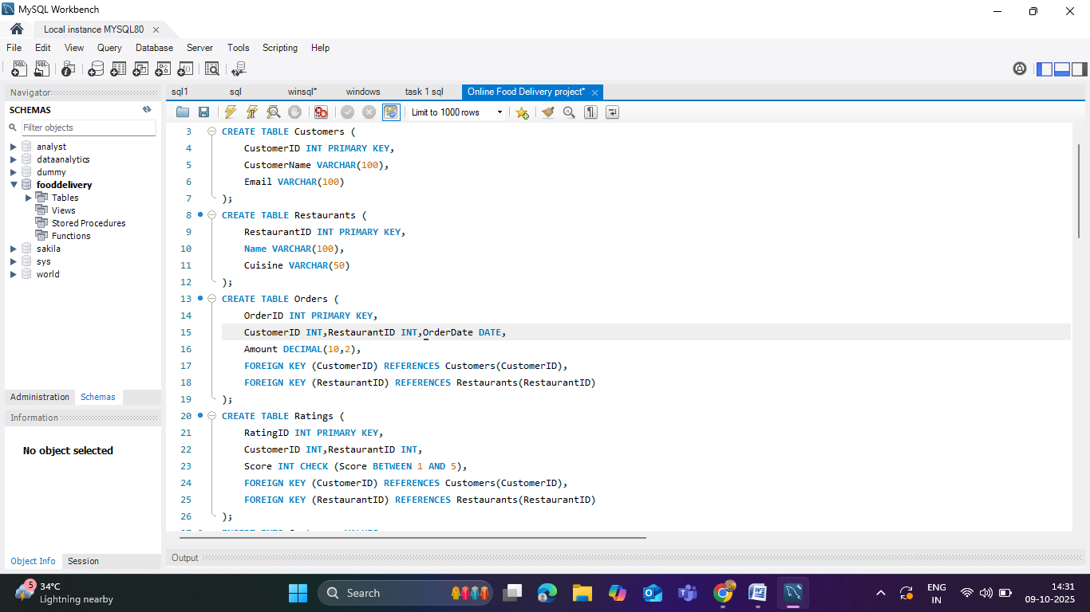

5. Data Inserted:
(From your SQL INSERTs, will include examples)

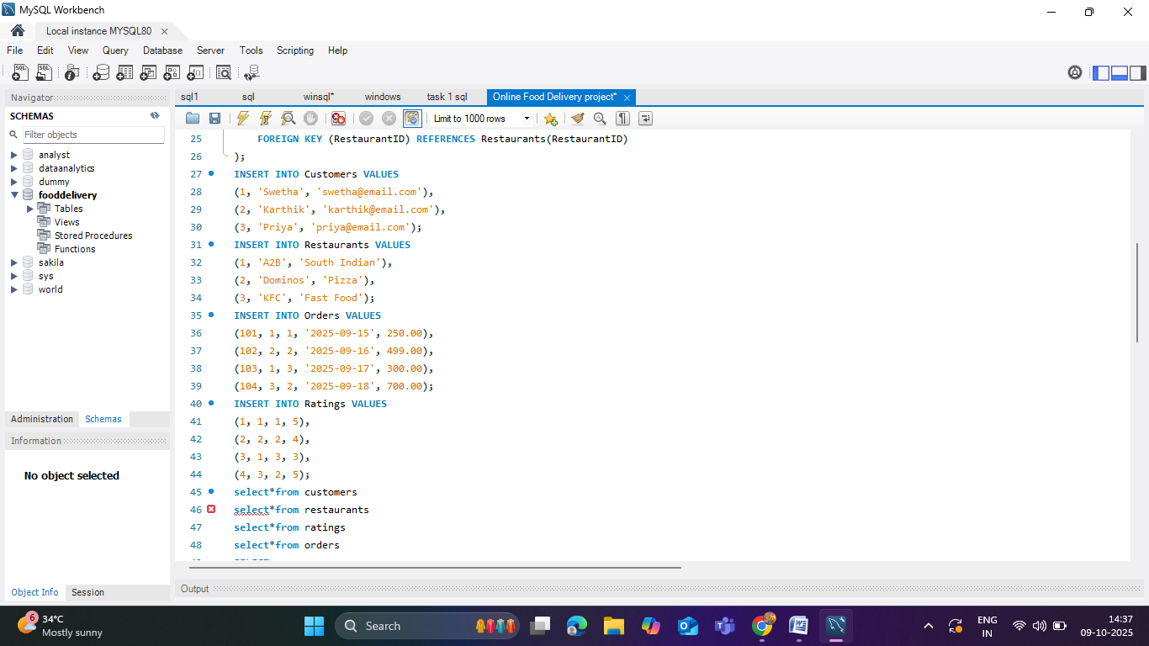

6. Data Exploration with SQL

Restaurant Performance
- Top restaurants by TotalOrders and revenue:
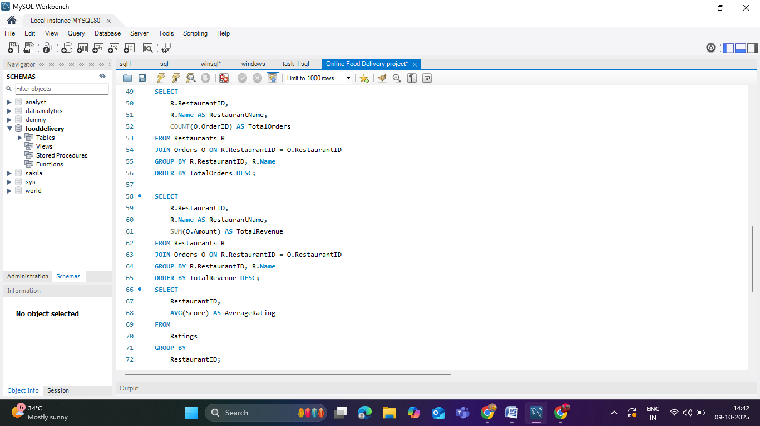
- Using AVG() to calculate average restaurant ratings

Customer Loyalty
- Customers who ordered multiple times:
- Loyalty ranking using RANK(),DENSE_RANK():
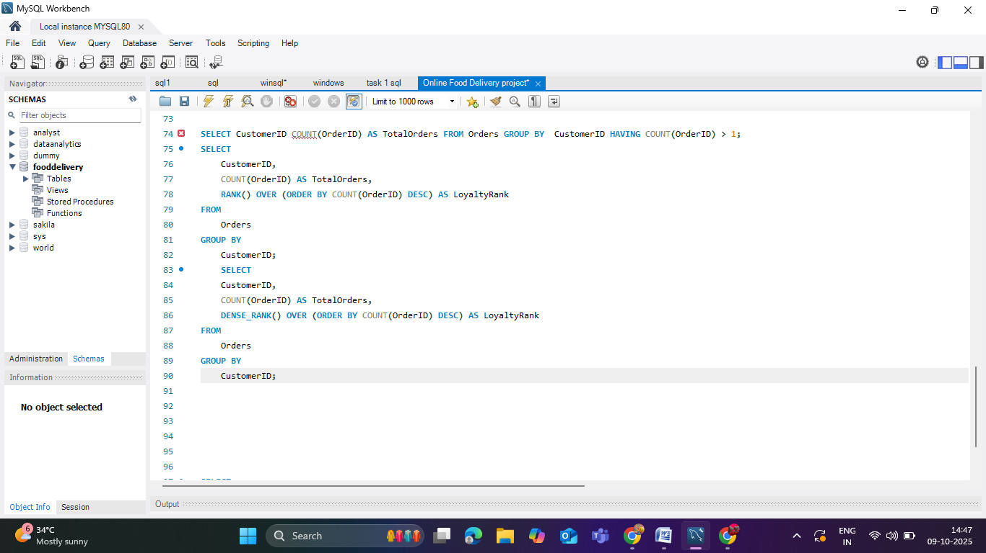

Order Trends
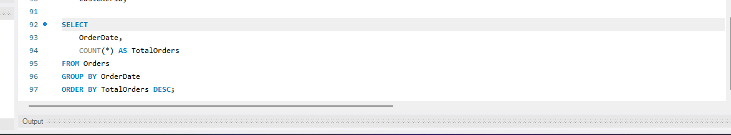
- Most popular order days Using GROUP BY and ORDER BY:

------------------------

